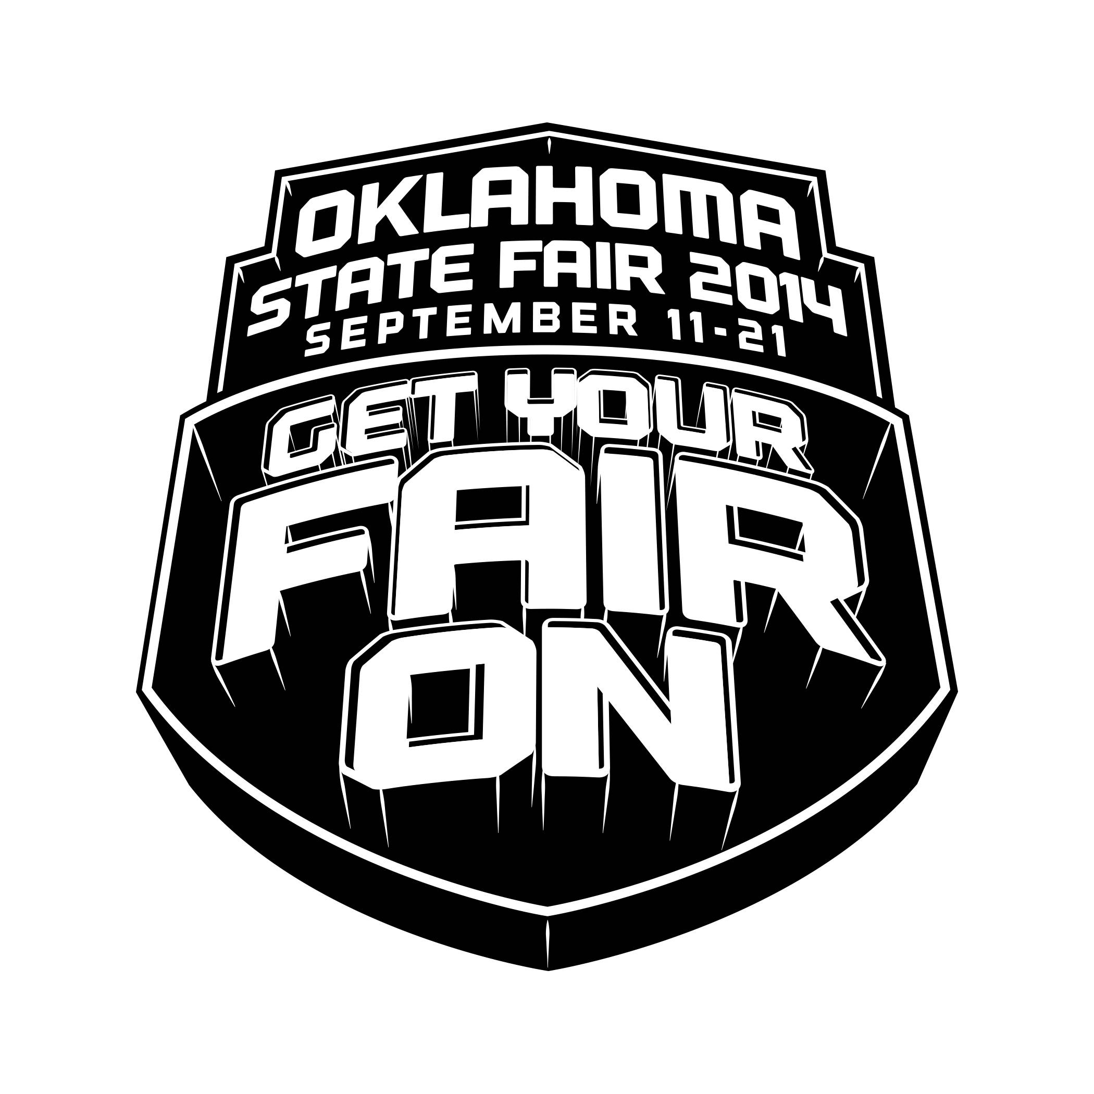

OKEDA

PRESENTS

OKLAHOMA STATE FAIR®
EQUESTRIAN DRILL COMPETITION

Friday, September 12th, 2014
State Fair Park - Performance Arena (Barn #6)
Oklahoma City, Oklahoma

ENTRY FEES: Large Teams $100.00 per Class

Small Teams $ 50.00 per Class

(Late Entry Fee after August 20, 2014 - $25.00)

STALL RESERVATIONS: STALLS ARE MANDATORY – ONE PER HORSE

1st Night: $25.00 per horse or tack stall

2nd Night: $10.00 per horse or tack stall
Arrival Times: Thursday September 11th, 2014 12:00 p.m. - 6:00 p.m.
Departure Time: NO LATER than Saturday September 13th, 2014 10:00 a.m.
**Stalls DO NOT Include Shavings**

REQUIRED FOR ALL HORSES: NEGATIVE COGGINS AND
HEALTH PAPERS

State Inspectors will be at the gate and will check EVERY horse entering State Fair Park. (Both documents are required for in-state horses, as well.)

IMPORTANT INFORMATION:

- Stalls are mandatory for all horses arriving or competing at Oklahoma State Fair. No tie outs permitted.

- Fair admission is required at the gate for all exhibitors, riders, visitors and guests unless you have purchased admission tickets in advance at another location. Please be prepared to pay in cash. Information regarding ticket availability, sales and prices is available at http://www.okstatefair.com/content/hoursadmissionsdiscounts

- Check-In Reminder – All Horses must enter thru Gate 7 via the Portland Avenue entrance only. Horses can arrive between 7:00 a.m. and 10:00 p.m. Please be prepared for long lines at the Horse/Livestock Inspector’s Gate 7 and allow yourself plenty of time to complete the arrival process.

- Pre-Entry Forms (postmarked by August 20, 2014) will be posted on www.okeda.weebly.com (Oklahoma State Fair General Requirements for all horse shows will be in effect, so please check their website for more information.)

- Oklahoma State Fair General Requirements for all horse shows will be in effect, so please check their website for more information.

For info email homesbyvicki25@yahoo.com or call (405) 623-3471 or visit our website at: www.okeda.weebly.com

September 15 - 25, 2011

ENTRY FORM

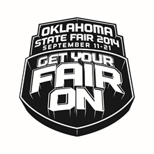
OKLAHOMA STATE FAIR®
EQUESTRIAN DRILL COMPETITION

Friday, September 12th, 2014
State Fair Park - Performance Arena (Barn #6)
Oklahoma City, Oklahoma

Name of Team: ____________ ____________________________________________________________
Contact Name: ________________________________________________________________________
Mailing Address: ________________________________________________________________________
Phone Number: ________________________________________________________________________
Email Address: ________________________________________________________________________
Number of Riders: ________________________________________________________________________

Classes Entered: CHECK all that apply:
Entry Fee $20 per team, per class. $25 late fee per class after August 20, 2014
Color Guard (No Points) $____________
Fun Drill (4 or more riders) $____________
Special Assist (No Points) $____________

Open *Lope/Canter*
Divisions:
Large (9 or more riders) $100 per class_____ Small (4-8 riders) $50 per class____

Classes:
Free Style $____________
Theme $____________
Rodeo $____________

~ Open Grand Champions will be determined by highest points in Three classes~
** $25 late fee per class after August 20, 2014**
Novice *Walk/ Trot*
Divisions:
Large (9 or more riders) $100 per class_____ Small (4-8 riders) $50 per class____

Classes:
Free Style $____________
Theme $____________
Rodeo $____________

~Small Team Grand Champions will be determined by highest points in Three classes~
** $25 late fee per class after August 20, 2014**
TOTAL – Class Entries (Total of Page #1): $__________________

***Notice: You must submit both Pages #1 and #2 to enter***
Page 1 of 3

Advance State Fair Tickets must be ordered by August 20, 2014, No Exceptions:

Adult Price: per day ($7.00 X ____ (# of adults) = $ _________
Ages 6 – 11: per day $(4.00 X ____ (# of youth) = $ _________

2014 OKLAHOMA STATE FAIR
TICKET PRICING PROGRAMMING GUIDE

Outside Gate: Advance Regular
Adult: $7 $10
Child (6-11): $4 $5
Child (5 and under): FREE, no ticket required
Season Pass: $25 $30
Season Parking (No trailers): $25 $25
Daily Parking: N/A $5
Opening Day: N/A $2 all persons
Tuesday: N/A $3 all persons
Corporate Bundles (sold in groups of 250+): $6/ticket

***Note*** If OKEDA reaches 250 Advanced Tickets then OKEDA will refund each team the difference of amount of the ticket paid for and actual cost of ticket.

TOTAL - Tickets: $__________________

Stalls:

Stalls for first day & night - $25 X ____ (# of stalls) = $___________

Stalls for first day & night w/T-Shirt- $37.00____ (# of Stalls) = $________
Youth- SM____ Med____ L_____ XL_____
Adult- SM____ Med____ L_____ XL_____

Additional day & night per stall - $10 X ___ (# of stalls) = $___________

*** Stalls DO NOT include shavings***
***Shavings can be purchased at Oklahoma State Fair Park upon arrival***

TOTAL - Stalls: $__________________

GRAND TOTAL (includes Class Entries Total on Page 1 and
Tickets & Stalls Totals on Page 2) $__________________

For info email homesbyvicki25@yahoo.com or call (405) 623-3471 or visit our website at: www.okeda.weebly.com

PAGE 2 of 3

WAIVER AND RELEASE: In consideration or acceptance of this application, the undersigned (and if the undersigned is a group), each and every member of the undersigned, participating in the competition hereby Releases, Discharges and Agrees to Indemnify Oklahoma State Fair, Inc. and its officers, directors and employees, and the City of Oklahoma City, the Oklahoma City Public Property Authority, and the OKEDA, and the members, agents and servants; (“Releases”) from any damage, whether caused by the actual or passive negligence of the Releases, while the undersigned is at State Fair Park and/or competing, observing, working in, or for any purposes participating at the Oklahoma State Fair, and forever discharges, and hereby agrees to indemnify and hold harmless of and from any and all loss, liability or damage arising out of any personal injury or property damage occurring to the applicants. The applicants are authorized to execute this WAIVER AND RELEASE, individually and on behalf of all persons and teams of which the applicant is comprised. The undersigned has read and voluntarily sigs this Release and waiver of liability and indemnity agreement. If under eighteen (18) years of age, signature of individual and parent or guardian is required. The undersigned are aware of and understand Oklahoma Statutes, Section 50 of Title 76 pertaining to the Oklahoma Livestock Liability Limitations Act. The person submitting this entry therein agrees to accept authority to act as agent for actual and/or recorded owner(s) of the animals being entered and, in doing so, indicates acceptance of all rules, regulations, liability limitations for all individuals as owner, trainer, agent, exhibitor, rider, handler and/or showman. The person submitting this entry accepts responsibility and verified accuracy of all information provided herein.

APPLICANTS:
(ALL TEAM MEMBERS AND LEGAL GUARDIANS MUST SIGN)

___________________________________ _____________________________________ _______________________________

___________________________________ _____________________________________ _______________________________

___________________________________ _____________________________________ _______________________________

___________________________________ _____________________________________ _______________________________

___________________________________ _____________________________________ _______________________________

___________________________________ _____________________________________ _______________________________

___________________________________ _____________________________________ _______________________________

___________________________________ _____________________________________ _______________________________

___________________________________ _____________________________________ _______________________________

DATE: _____________________

For info email homesbyvicki25@yahoo.com or call
(405) 623-3471 or visit our website at: www.okeda.weebly.com

Send ALL Three of the entry forms and a check or money order payable to “OKEDA” to:

Oklahoma State Fair Equestrian Drill Competition
C/o Vicki Foster
P.O. Box 554
Wheatland, OK 73097

Page 3 of 3

